**Lab Report-11**

**Experiment Name:**

Priority Scheduling Algorithm.

**Aim and Object:**

1. To know about the working procedure of Priority Scheduling Algorithm.
2. To implement the Priority Scheduling Algorithm program in C++ and check its following output

**Theory:**

Priority Scheduling Algorithm

* Priority scheduling is a non-preemptive algorithm and one of the most common scheduling algorithms in batch systems.
* Each process is assigned a priority. Process with highest priority is to be executed first and so on.
* Processes with same priority are executed on first come first served basis.
* Priority can be decided based on memory requirements, time requirements or any other resource requirement.

**Example:**

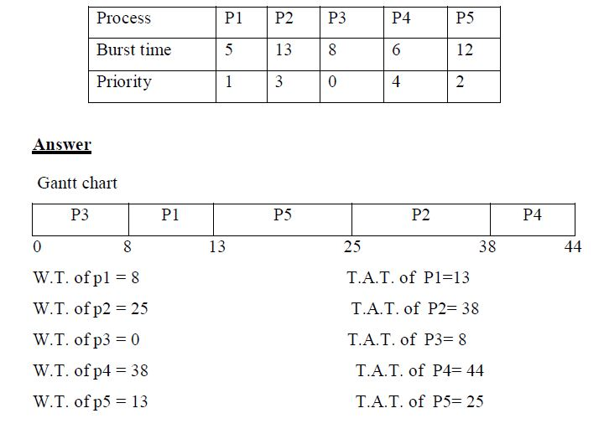

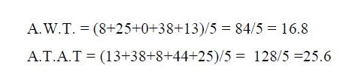

**Program of priority scheduling :**

#include<stdio.h>

int main()

{

int bt[20],p[20],wt[20],tat[20],pr[20],i,j,n,total=0,pos,temp,avg_wt,avg_tat;

printf("Enter Total Number of Process:");

scanf("%d",&n);

printf("\nEnter Burst Time and Priority\n");

for(i=0;i<n;i++)

{

printf("\nP[%d]\n",i+1);

printf("Burst Time:");

scanf("%d",&bt[i]);

printf("Priority:");

scanf("%d",&pr[i]);

p[i]=i+1; //contains process number

}

//sorting burst time, priority and process number in ascending order using selection sort

for(i=0;i<n;i++)

{

pos=i;

for(j=i+1;j<n;j++)

{

if(pr[j]<pr[pos])

pos=j;

}

temp=pr[i];

pr[i]=pr[pos];

pr[pos]=temp;

temp=bt[i];

bt[i]=bt[pos];

bt[pos]=temp;

temp=p[i];

p[i]=p[pos];

p[pos]=temp;

}

wt[0]=0; //waiting time for first process is zero

//calculate waiting time

for(i=1;i<n;i++)

{

wt[i]=0;

for(j=0;j<i;j++)

wt[i]+=bt[j];

total+=wt[i];

}

avg_wt=total/n; //average waiting time

total=0;

printf("\nProcess\t Burst Time \tWaiting Time\tTurnaround Time");

for(i=0;i<n;i++)

{

tat[i]=bt[i]+wt[i]; //calculate turnaround time

total+=tat[i];

printf("\nP[%d]\t\t %d\t\t %d\t\t\t%d",p[i],bt[i],wt[i],tat[i]);

}

avg_tat=total/n;

printf("\n\nAverage Waiting Time=%d",avg_wt);

printf("\nAverage Turnaround Time=%d\n",avg_tat);

return 0;

}

**Output:**

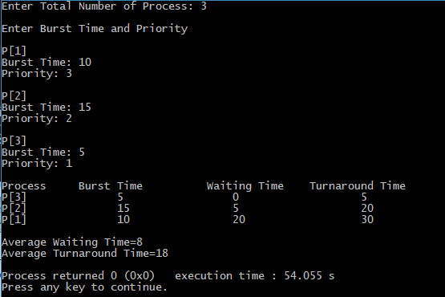

**Conclusion:**

From this Lab I know about Priority Scheduling Algorithm. Priority scheduling is a non-preemptive algorithm and one of the most common scheduling algorithms in batch systems. Each process is assigned apriority. Process with the highest priority is to be executed first and so on. Processes with the same priority are executed on first come first served basis. Also knowing about the working procedure of priority Scheduling Algorithm. Finally I have to do it successfully.